Midweek Meander 27 April 2023

Today’s meander started off with morning tea at Pasta in the Valley as a meeting place and then on to The Lakes roadhouse along Great Eastern Highway.
The weather looked threatening but did not break all day. The roads were dry and no rain dared to dampen the cars or our spirits. We had three drivers today willing to risk it.
Apologies received from Kent Bush, Peter Hall and Roger Bennetts. Sounded like they really wanted to come but life got in the way this time.
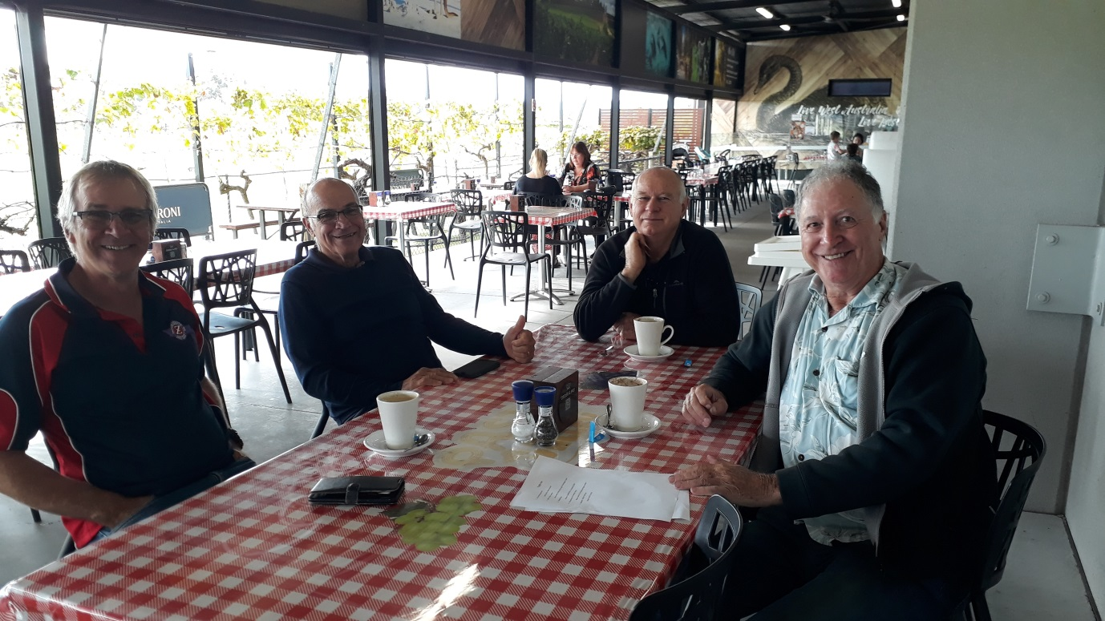
We were graced with the presence of the owner of Pasta in the Valley for a morning tea chat about why things were so much better before!!
Left to right: Mick Hailand, The Big Boss, Paul Maisey, Tony Murphy.
This time we have added a small competition for spotting 5 road signs along the way. Tony is holding the hint sheets.
After a couple of hours, and before we settled in for the day, we decided to move on and head up Greenmount Hill on the way to The Lakes roadhouse.
Three Z’s roared up the hill in the outside lane. One 240Z, one 260Z and one 280ZX – all three marques together.
Outside Sawyers Valley we were able to blow out the cobwebs from under the cars until we reached The Lakes roadhouse and parked.
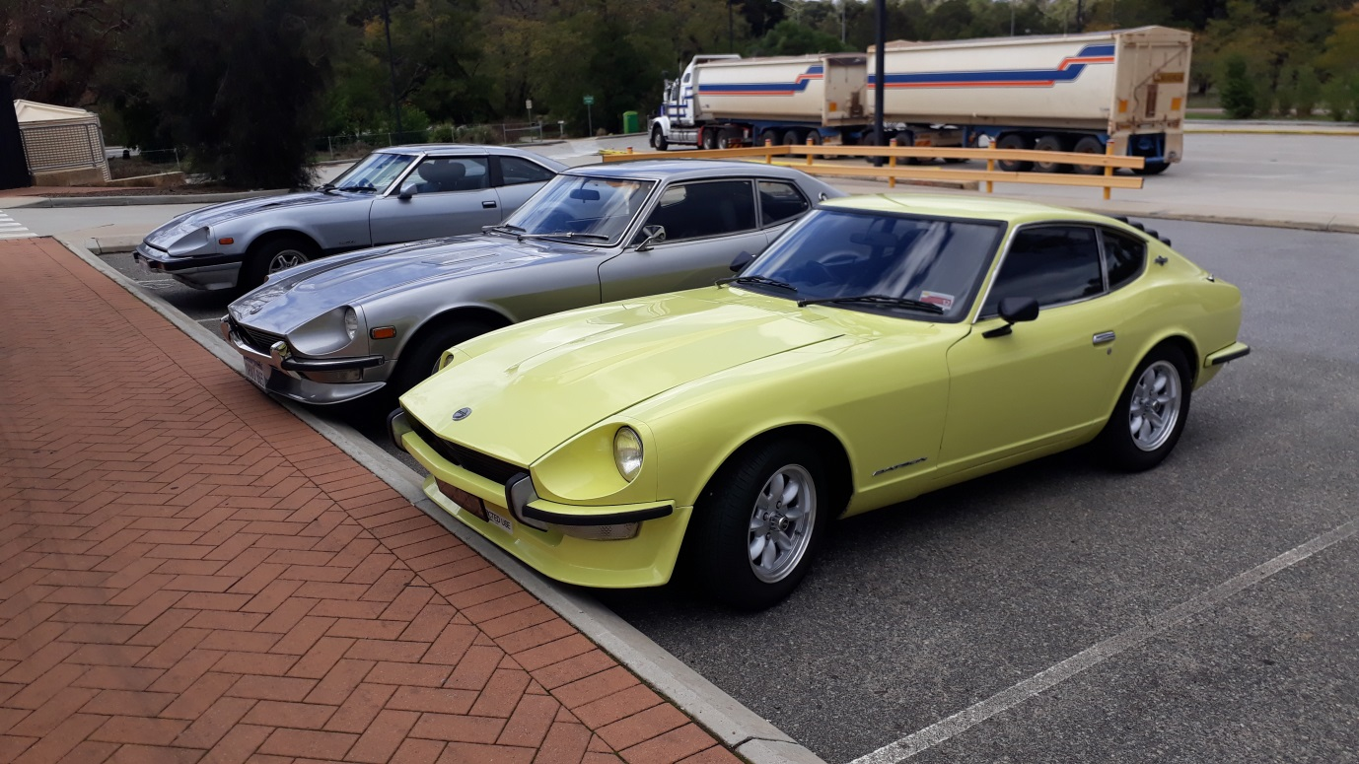
Mick’s 240Z has just been run in and was happy to get out and about. It has a chassis number of S30-000105!!!
Paul has just completed the full nut and bolt restoration of his silver 260Z 2+2 up in Glen Forrest. It had been on the rotisserie for two and a half years.
The 280ZX in the background is watching them both like a big brother.
Competition hint sheet was a bit cryptic but Mick ended up with the greater score and got the prize.
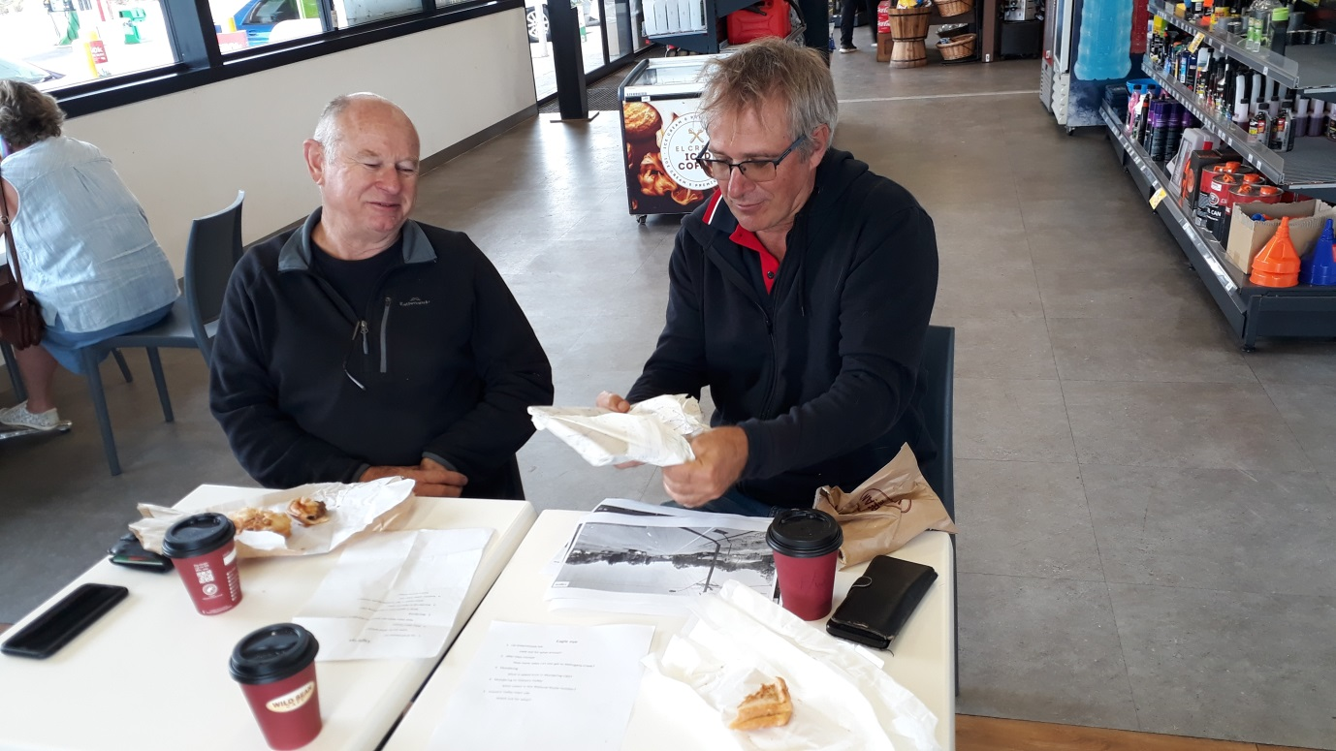
After lunch and much Datsun tragic’s topical discussion it was back to Perth and down the hill once more. Cars garaged by about 3pm.

